

Mini Project Report

Course Title: Computer Networks
Course code: CSE405
Section: 07
Semester: Summer 2025

Mini Project Title:
"Design and Simulation of EWUX University Multi-Campus Network"

Submitted To | Submitted By
Md. Arman Hossain  Lecturer  Department of Computer Science & Engineering, EWU | - Asifa Akter Liya (2022-3-60-186)  - Benazir Meem (2022-3-60-169)

Submission Date: 05 September 2025.

Design Rationale of the University Campus Network
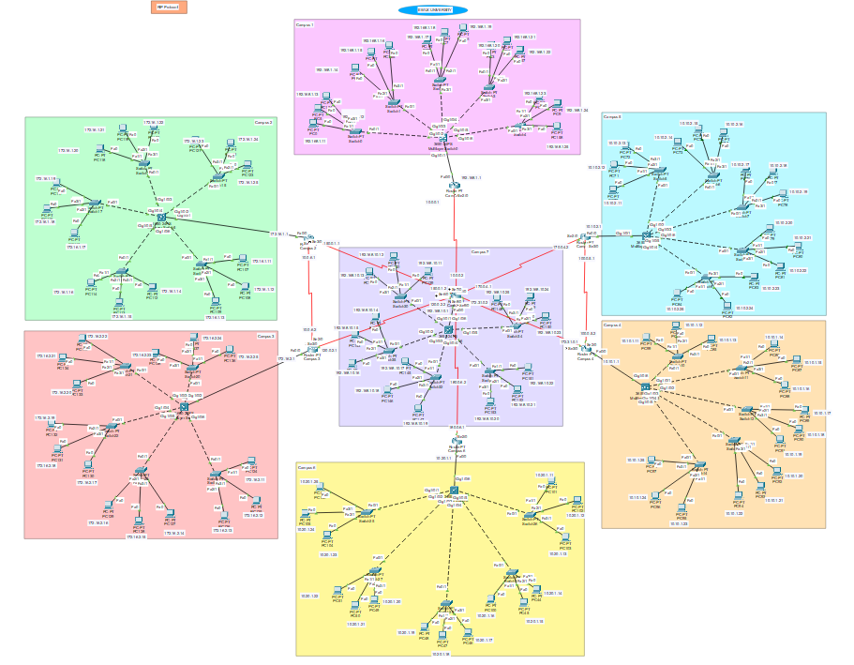
The university network is designed to connect seven campuses through a combination of routers and serial links, forming a structured and scalable backbone. Each campus has its own LAN, with PCs connected via switches to a router, allowing local communication and access to other campuses.
- Hierarchical design: Each campus LAN is connected to a router, which then links to other campuses through Router 7 acting as a central hub. This ensures organized traffic flow and simplifies network management.
- Dynamic routing (RIP or OSPF): Used to automatically share routing information, allowing all campuses to communicate without manually configuring static routes.
- Subnetting: Each campus LAN and inter-router link is subnetted to efficiently allocate IP addresses and avoid overlaps, while providing enough hosts per network.
- Scalability: New campuses or hosts can be added easily by configuring additional subnets and connecting to the central router hub.
- Redundancy & flexibility: Router 7 provides a central connection point, making it easier to reroute traffic if one path fails, ensuring continuous connectivity.
- Practical setup for testing: The design allows for testing ping, tracert, and routing protocols to verify connectivity, path selection, and network behavior.
Summary:
This design balances simplicity, scalability, and manageability, while ensuring all campuses can communicate efficiently and future expansions can be accommodated with minimal changes.
Requirements:
- 7 Routers
- 7 Multilayer-Switches
- 35 Switches
- 105 PCs
- DHCP Server (Dynamic Host Configuration Protocol)
- DNS Server (Domain Name System)
- WEB Server
- Straight Through Cable
- Serial DCE Cable

Full IP Address Plan for 7-Campus Network

Campus 1 (R1)
Router LAN IP: 192.168.1.1/24

Campus 2 (R2)
Router LAN IP: 172.16.1.1/24

Campus 3 (R3)
Router LAN IP: 172.16.2.1/24

Campus 4 (R4)
Router LAN IP: 10.10.1.1/24

Campus 5 (R5)
Router LAN IP: 10.10.2.1/24

Campus 6 (R6)
Router LAN IP: 10.20.1.1/24

Campus 7 (Central Hub, R7)
Router LAN IP: 192.168.10.1/24

Router Configuration:
Campus 1:
enable
conf t
interface FastEthernet0/0
ip address 192.168.1.1 255.255.255.0
no shutdown
exit

interface Serial2/0
ip address 10.0.0.1 255.255.255.252
clock rate 64000
no shutdown
exit

end
write memory

Campus 2:
enable
conf t
interface FastEthernet0/0
ip address 172.16.1.1 255.255.255.0
no shutdown
exit

interface Serial2/0
ip address 10.0.6.1 255.255.255.252
no shutdown
exit

interface Serial3/0
ip address 150.0.1.1 255.255.255.252
no shutdown
exit

end
write memory
Campus 3:
enable
conf t
interface FastEthernet0/0
ip address 172.16.2.1 255.255.255.0
no shutdown
exit

interface Serial2/0
ip address 10.0.6.2 255.255.255.252
no shutdown
exit

interface Serial3/0
ip address 120.0.2.1 255.255.255.252
clock rate 64000
no shutdown
exit
end
write memory
Campus 4:
enable
conf t
interface FastEthernet0/0
ip address 10.10.1.1 255.255.255.0
no shutdown
exit

interface Serial2/0
ip address 100.0.5.2 255.255.255.252
no shutdown
exit

interface Serial3/0
ip address 172.31.0.1 255.255.255.252
clock rate 64000
no shutdown
exit

end
write memory
Campus 5:
enable
conf t
interface FastEthernet0/0
ip address 10.10.2.1 255.255.255.0
no shutdown
exit

interface Serial2/0
ip address 170.0.4.2 255.255.255.252
no shutdown
exit

interface Serial3/0
ip address 100.0.5.1 255.255.255.252
clock rate 64000
no shutdown
exit

end
write memory
Campus 6:
enable
conf t
interface FastEthernet0/0
ip address 10.20.1.1 255.255.255.0
no shutdown
exit

interface Serial2/0
ip address 180.0.6.1 255.255.255.252
no shutdown
exit

end
write memory
Campus 7:
enable
conf t
interface FastEthernet0/0
ip address 192.168.10.1 255.255.255.0
no shutdown
exit

interface Serial2/0
ip address 10.0.0.2 255.255.255.252
clock rate 64000
no shutdown
exit

interface Serial3/0
ip address 150.0.1.2 255.255.255.252
clock rate 64000
no shutdown
exit

interface Serial6/0
ip address 120.0.2.2 255.255.255.252
no shutdown
exit

interface Serial9/0
ip address 180.0.6.2 255.255.255.252
clock rate 64000
no shutdown
exit

interface Serial8/0
ip address 172.31.0.2 255.255.255.252
no shutdown
exit

interface Serial7/0
ip address 170.0.4.1 255.255.255.252
clock rate 64000
no shutdown
exit

end
write memory

RIP configuration:
Campus 1:
router rip
version 2
no auto-summary
network 192.168.1.0
network 10.0.0.0

Camous 2:
router rip
version 2
no auto-summary
network 172.16.1.0
network 10.0.6.0
network 150.0.1.0
Campus 3:
router rip
version 2
no auto-summary
network 172.16.2.0
network 10.0.6.0
network 120.0.2.0
Campus 4:
router rip
version 2
no auto-summary
network 172.31.0.0
network 100.0.5.0
network 10.10.1.0
Campus 5:
router rip
version 2
no auto-summary
network 170.0.4.0
network 10.10.2.0
network 100.0.5.0
Campus 6:
router rip
version 2
no auto-summary
network 180.0.6.0
network 10.20.1.0
Campus 7:
router rip
version 2
no auto-summary
network 10.0.0.0
network 150.0.1.0
network 120.0.2.0
network 180.0.6.0
network 172.31.0.0
network 170.0.4.0
network 192.168.10.0

Ping(RIP Protocol):
Campus 1 to campus 7:
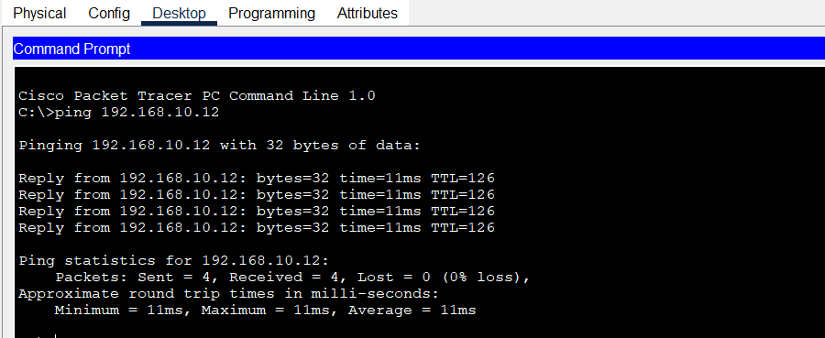
Campus 7 to campus 3:
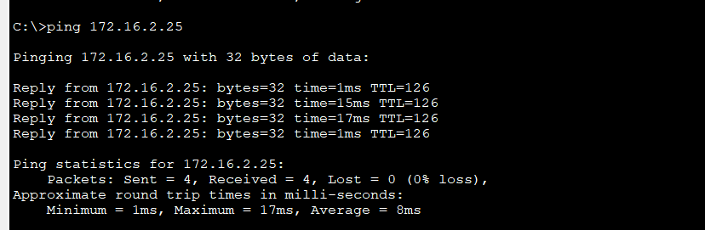
Campus 4 to campus 5:
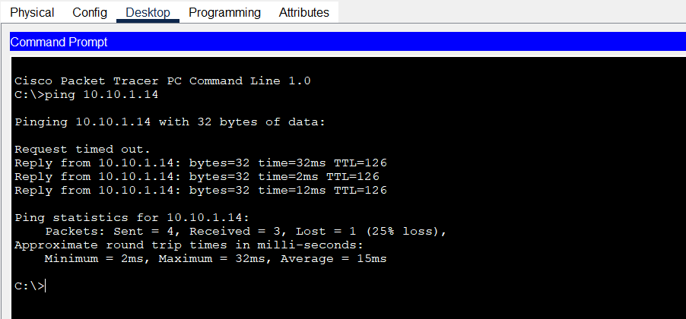
Campus 5 to campus 7:
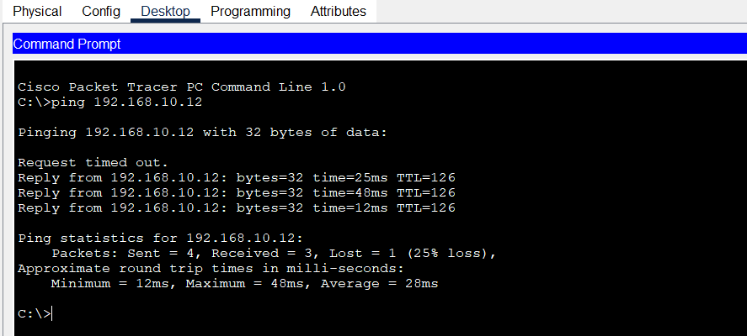
Campus 6 to Campus 1:
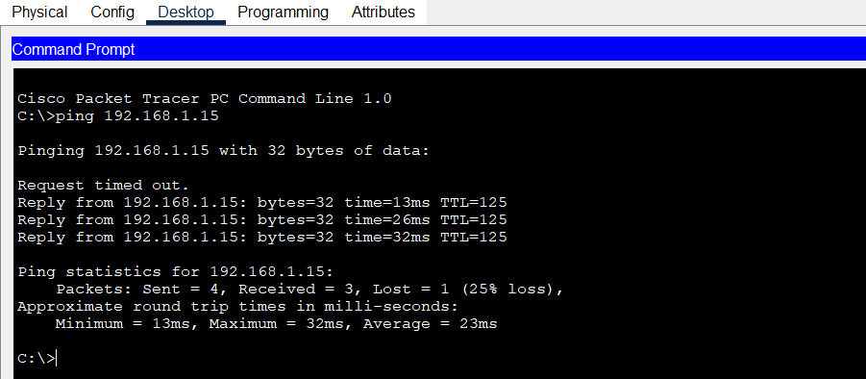
Campus 3 to Campus 5:
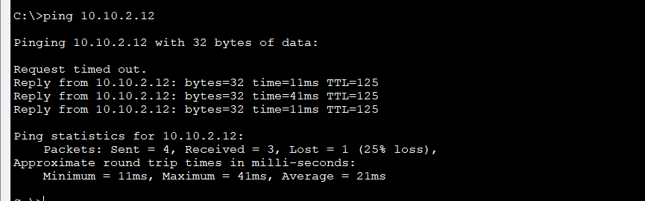
Campus 4 to Campus 3:
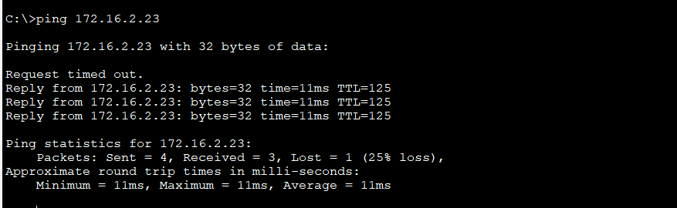

OSPF Configuration:
Campus 1:
router ospf 1
network 192.168.1.0 0.0.0.255 area 0
network 10.0.0.0 0.0.0.3 area 0
exit
Campus 2:
router ospf 1
network 172.16.1.0 0.0.0.255 area 0
network 10.0.6.0 0.0.0.3 area 0
network 150.0.1.0 0.0.0.3 area 0
exit
Campus 3:
router ospf 1
network 172.16.2.0 0.0.0.255 area 0
network 10.0.6.0 0.0.0.3 area 0
network 120.0.2.0 0.0.0.3 area 0
exit
Campus 4:
router ospf 1
network 10.10.1.0 0.0.0.255 area 0
network 100.0.5.0 0.0.0.3 area 0
network 172.31.0.0 0.0.0.3 area 0
exit
Campus 5:
router ospf 1
network 10.10.2.0 0.0.0.255 area 0
network 170.0.4.0 0.0.0.3 area 0
network 100.0.5.0 0.0.0.3 area 0
exit
Campus 6:
router ospf 1
network 10.20.1.0 0.0.0.255 area 0
network 180.0.6.0 0.0.0.3 area 0
exit
Campus 7:
router ospf 1
network 192.168.10.0 0.0.0.255 area 0
network 10.0.0.0 0.0.0.3 area 0
network 150.0.1.0 0.0.0.3 area 0
network 120.0.2.0 0.0.0.3 area 0
network 180.0.6.0 0.0.0.3 area 0
network 172.31.0.0 0.0.0.3 area 0
network 170.0.4.0 0.0.0.3 area 0
exit

Ping (OSPF Protocol)
Campus 6 to campus 1:
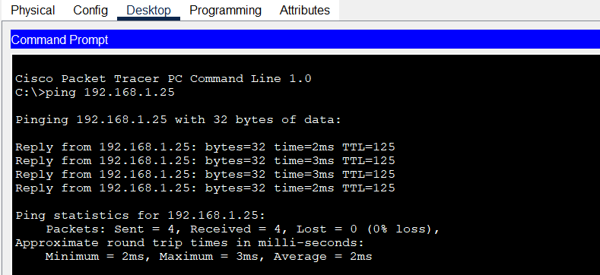
Campus 3 to campus 7:
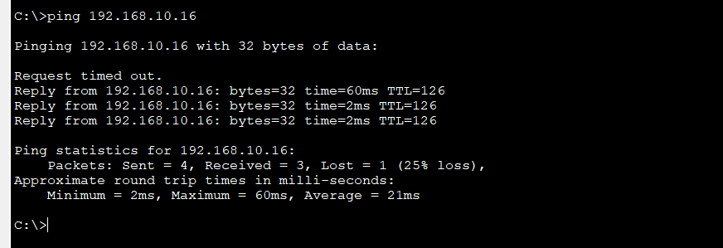
Campus 7 to campus 4:
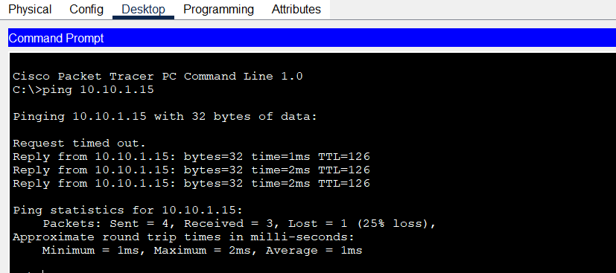
Campus 5 to campus 7:
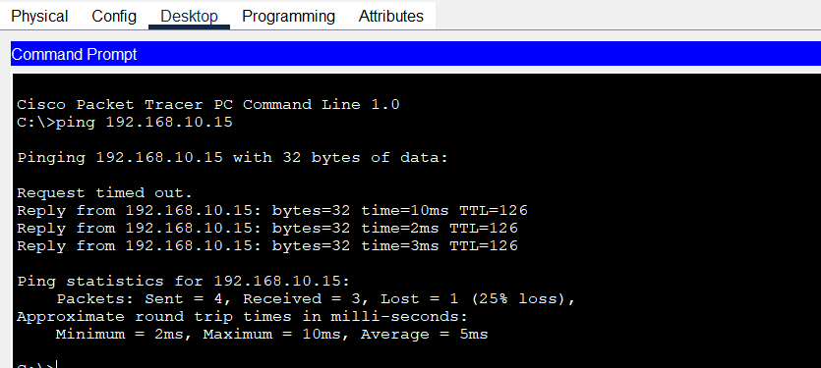
Campus 5 to campus 4:
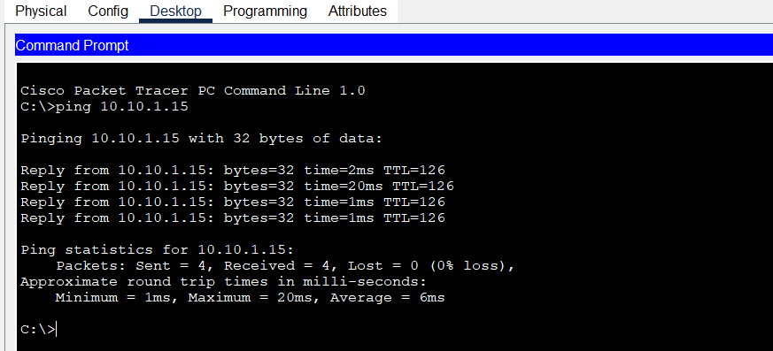

Campus 3 to campus 5:
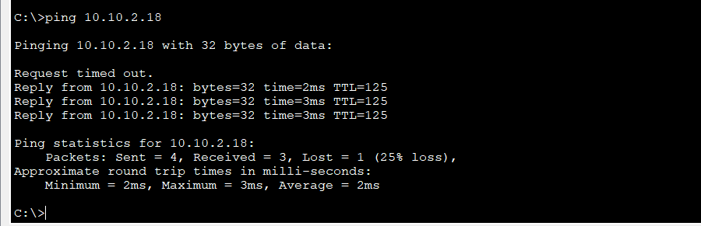
Campus 1 to campus 5:
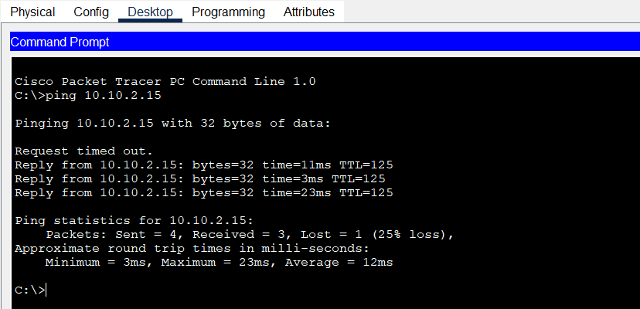

Route Table (OSPF Protocol)
Route table of Campus 1:
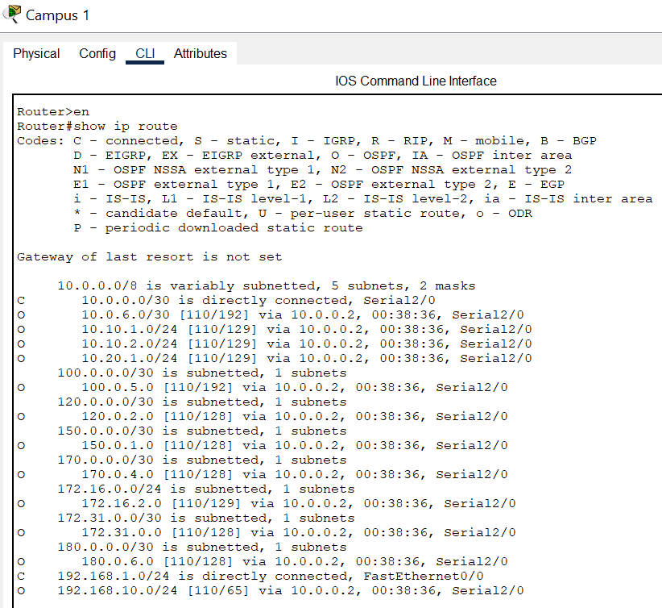
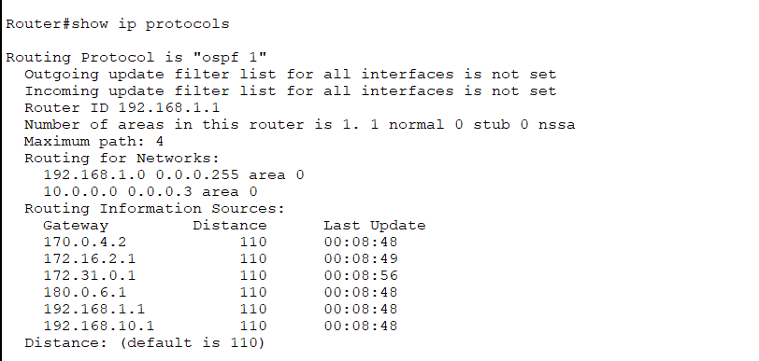
Route table of Campus 2:
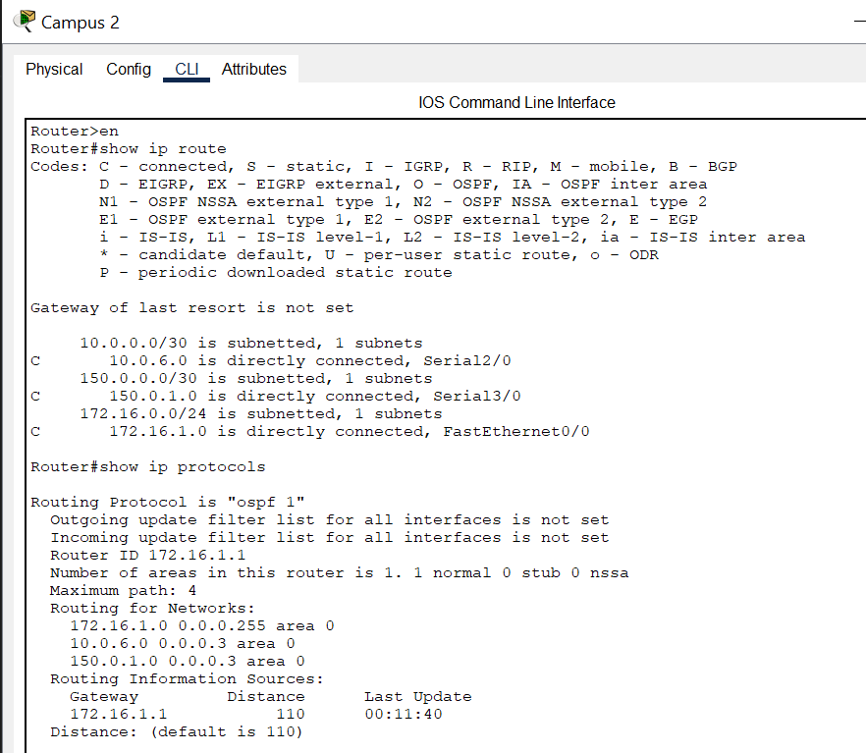

Route table of Campus 3:
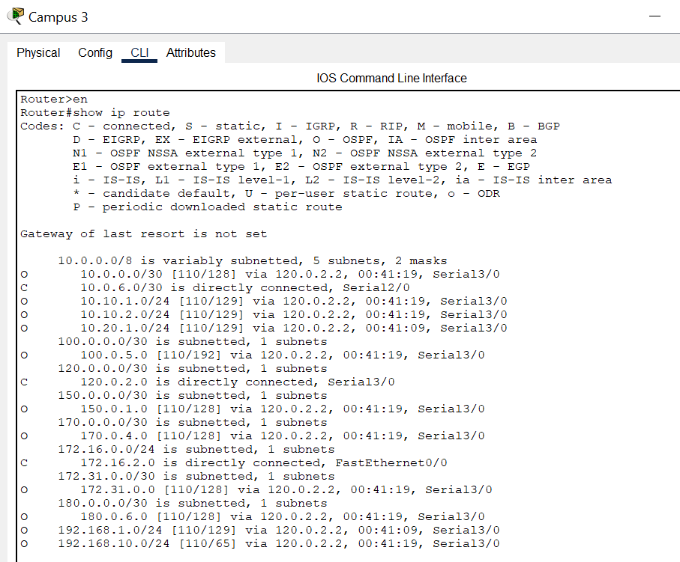
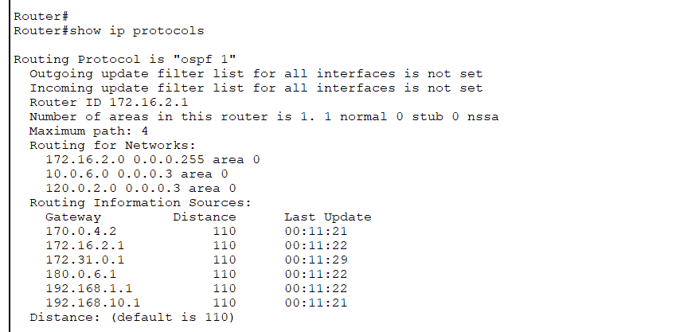

Route table of Campus 4:
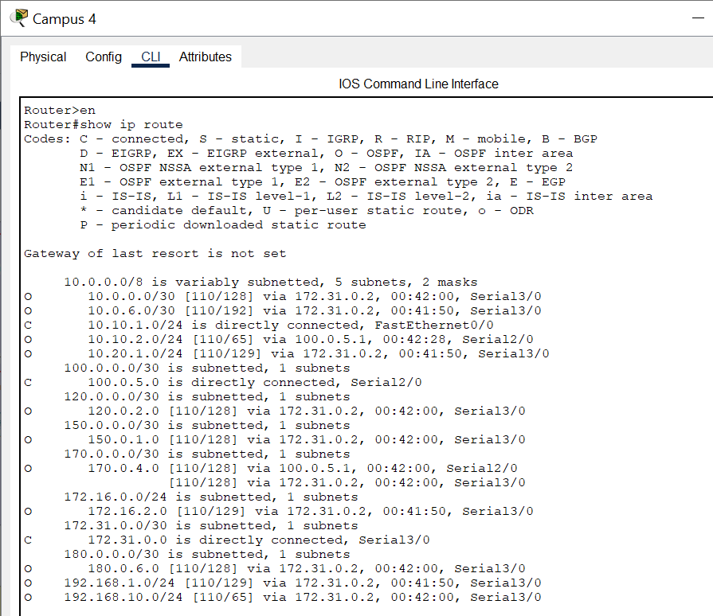
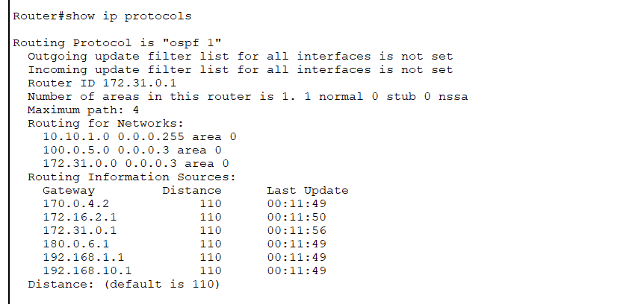

Route table of Campus 5:
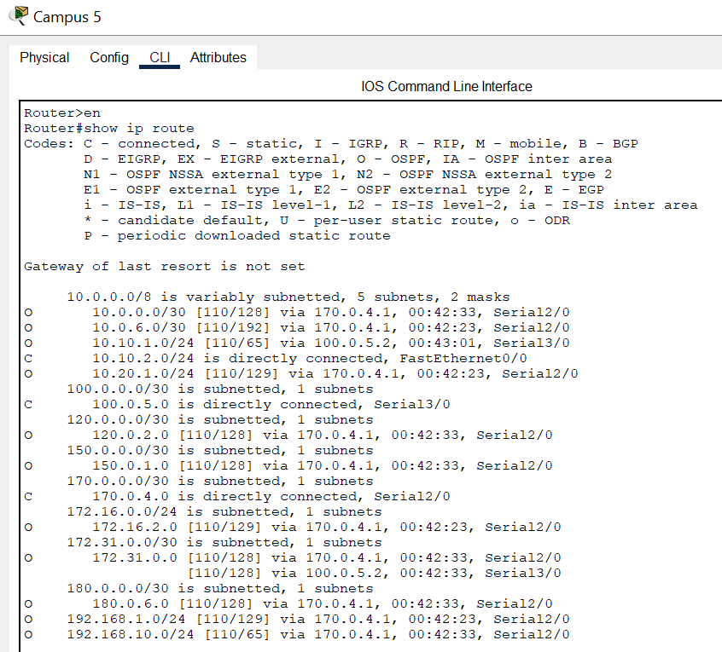
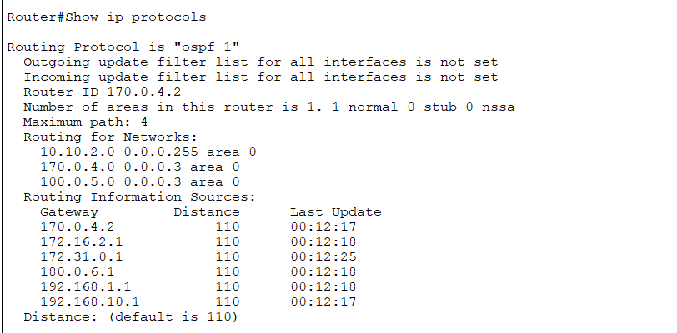
Route table of Campus 6:
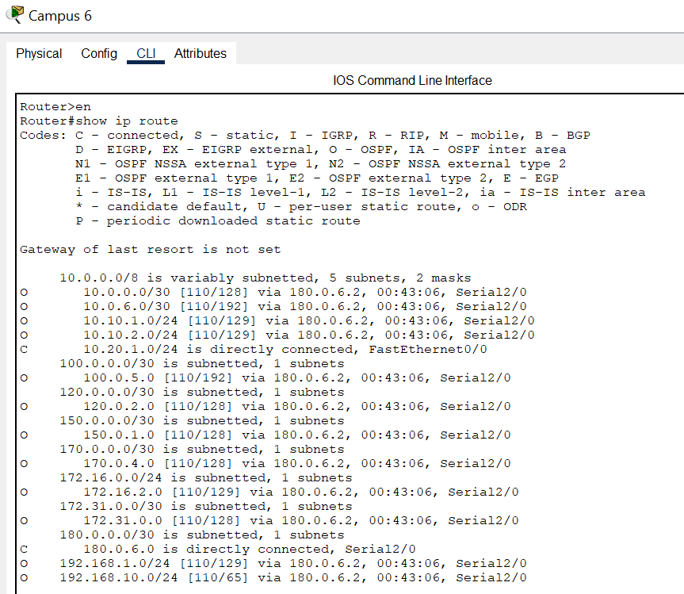
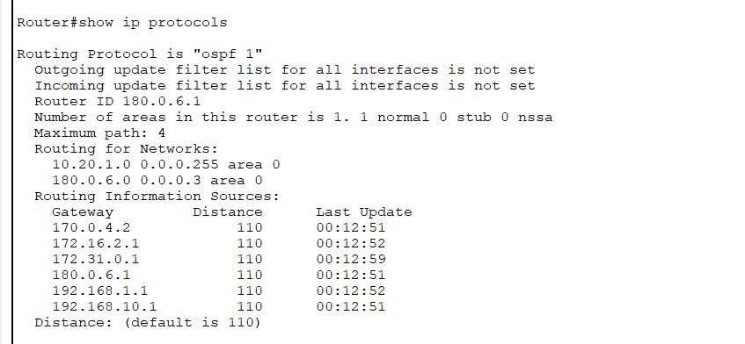

Route table of Campus 7:
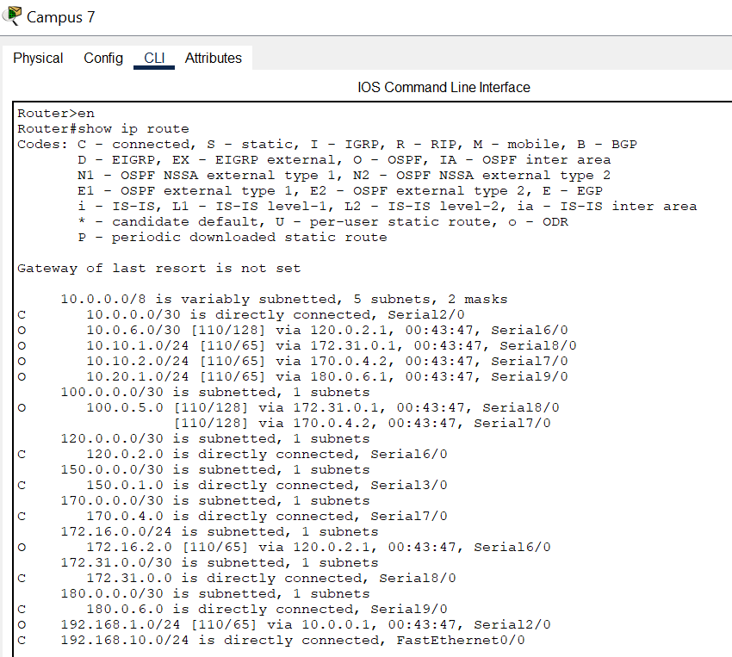
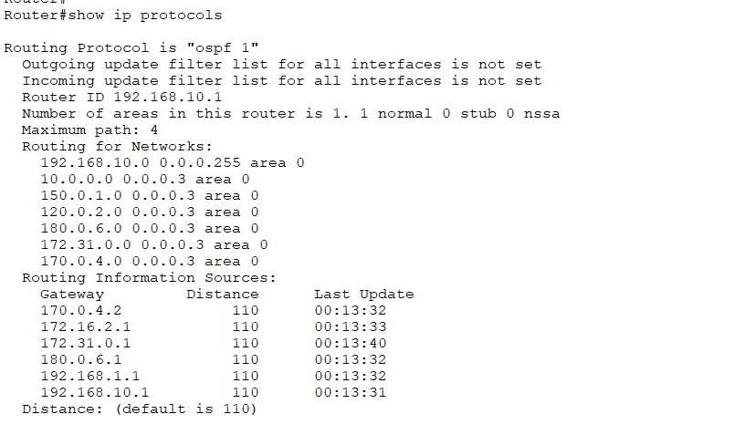

OSPF Path Verification (Using Tracert)
Test | Source → Destination | Expected OSPF Path | Explanation
1 | Campus 1 PC (192.168.1.11) → Campus 2 PC (172.16.1.11) | R1 → R7 → R2 | OSPF selects the direct path via R7 as the lowest-cost route.
2 | Campus 1 PC(192.168.1.11) → Campus 3 PC (172.16.2.11) | R1 → R7 → R3 | Packets pass through R7, which connects both R1 and R3.
3 | Campus 2 PC(172.16.1.11) → Campus 5 PC (10.10.2.11) | R2 → R7 → R5 | OSPF cost metric makes R7 the central router for this path.
4 | Campus 3 PC(172.16.2.11) → Campus 6 PC (10.20.1.11) | R3 → R7 → R6 | The serial link through R7 is the lowest-cost option.
5 | Campus 4 PC (10.10.1.11) → Campus 1 PC (192.168.1.11) | R4 → R7 → R1 | OSPF shortest-path calculation routes via R7.

EIGRP Configuration:
Campus 1:
enable
conf t

router eigrp 1
network 192.168.1.0
network 10.0.0.0
no auto-summary
exit
end
write memory

Campus 2:

enable
conf t

router eigrp 1
network 172.16.1.0
network 10.0.6.0
network 150.0.1.0
no auto-summary
exit
end
write memory

Camous 3:

enable
conf t

router eigrp 1
network 172.16.2.0
network 10.0.6.0
network 120.0.2.0
no auto-summary
exit
end
write memory

Campus 4:

enable
conf t

router eigrp 1
network 10.10.1.0
network 100.0.5.0
network 172.31.0.0
no auto-summary
exit
end
write memory

Campus 5:
enable
conf t

router eigrp 1
network 10.10.2.0
network 170.0.4.0
network 100.0.5.0
no auto-summary
exit
end
write memory

Campus 6:
enable
conf t

router eigrp 1
network 10.20.1.0
network 180.0.6.0
no auto-summary
exit
end
write memory

Campus 7:

enable
conf t

router eigrp 1
network 192.168.10.0
network 10.0.0.0
network 150.0.1.0
network 120.0.2.0
network 180.0.6.0
network 172.31.0.0
network 170.0.4.0
network 192.168.1.0
no auto-summary
exit
end
write memory

Ping (EIGRP Protocol):
Campus 1 to Campus 5:
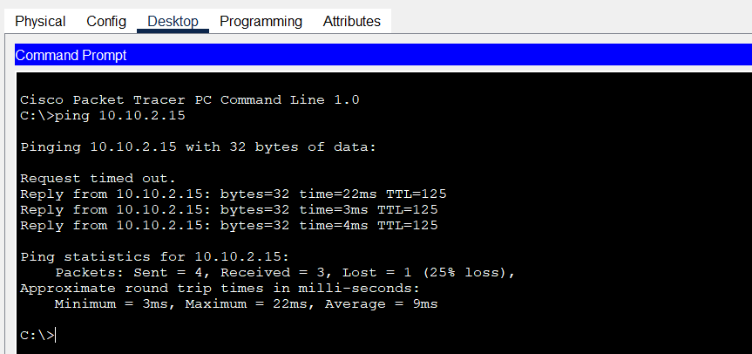

Campus 4 to Campus 5:
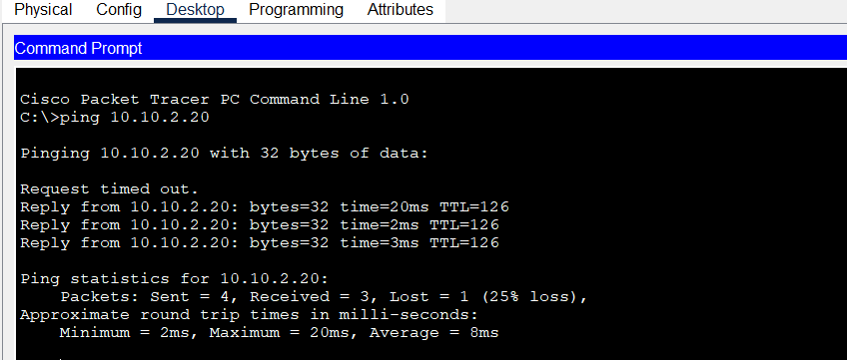

EIGRP ping:

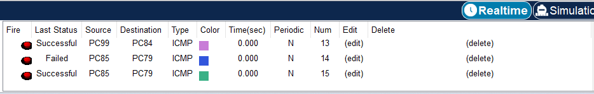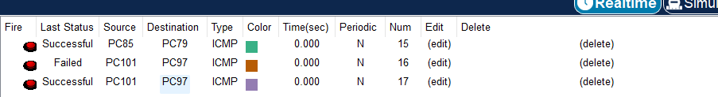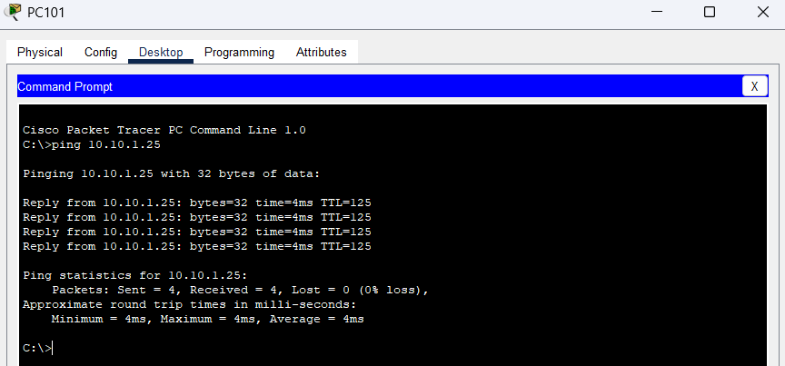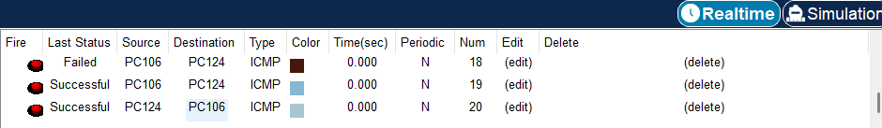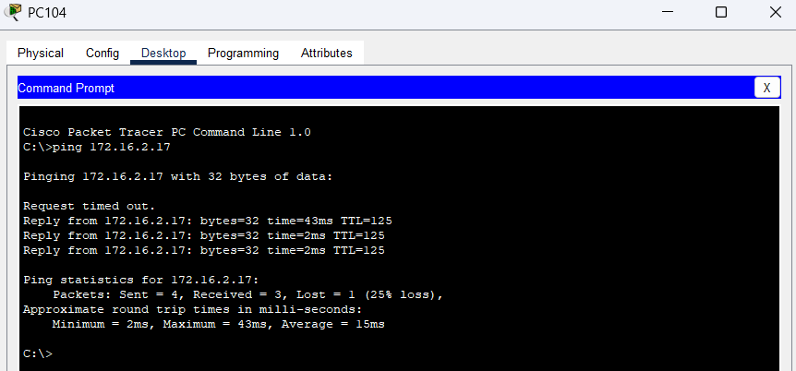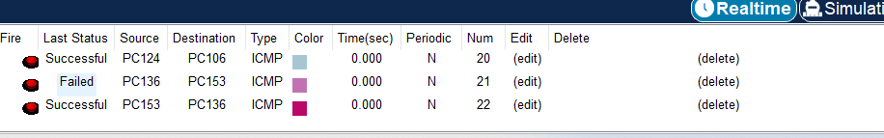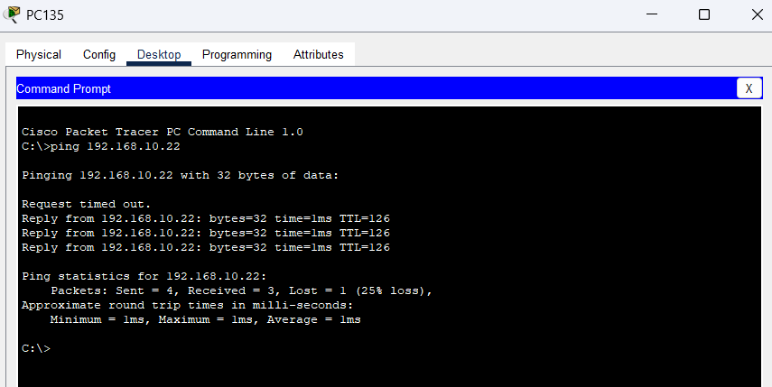

DHCP & DNS Server Configuration:
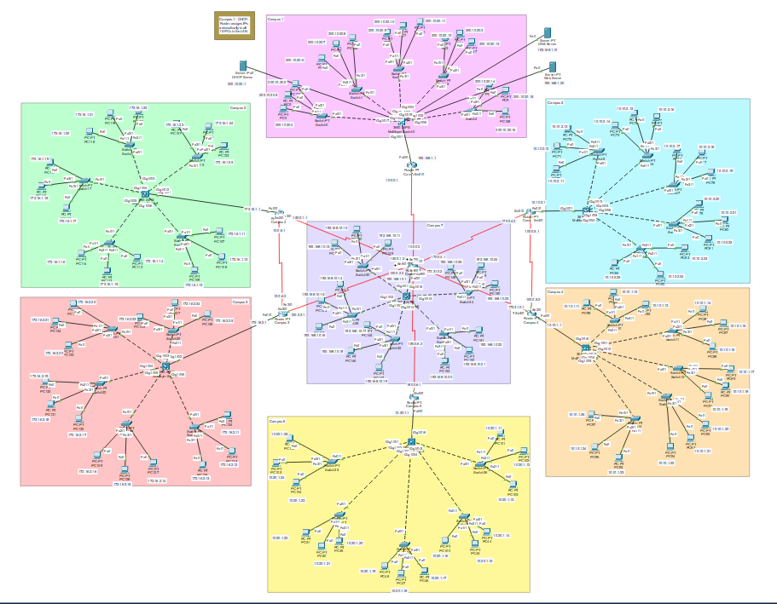
DHCP Configuration in Campus 1 :
In Campus 1, a DHCP server is used to assign IP addresses to all PCs in the LAN automatically. The router is configured as the default gateway, and the DHCP pool is created with the subnet 200.10.20.0/27, allowing up to 30 usable IP addresses, which is sufficient for the 15 connected PCs. This setup simplifies IP management, ensures unique addresses, and reduces manual configuration errors.
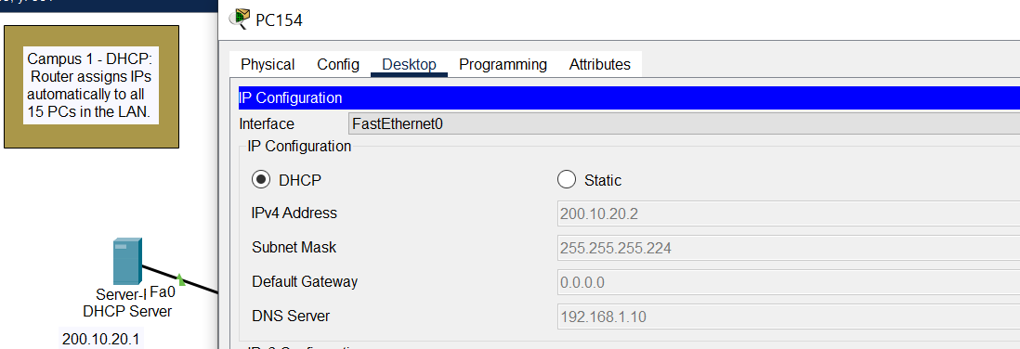

DNS Configuration:

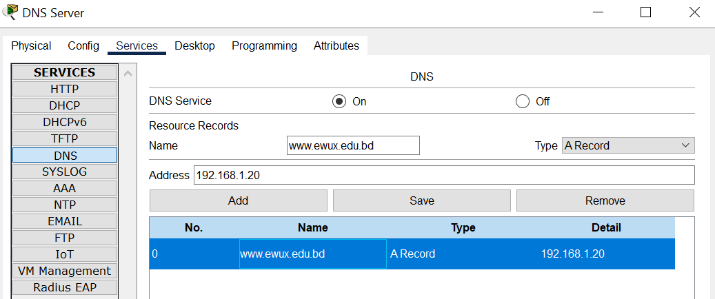
Observation:
I have correctly configured the DNS server and the Web server in Campus 1. However, when trying to browse the website www.ewux.edu.bd from any PC in Campus 1, the browser shows “host name unresolved.”
Reason:
This issue occurs because the DNS server is not resolving the hostname to the IP address of the web server. This can happen if the DNS entry for www.ewux.edu.bd was not properly mapped to the web server’s IP, or if the PCs are not correctly pointing to the DNS server’s IP in their network settings.

Comparisons
- RIP:
  - Uses hop count as metric.
  - Slow convergence, limited to 15 hops.
  - Routing tables show simple, classful entries.
- EIGRP:
  - Uses composite metric (bandwidth & delay).
  - Faster convergence than RIP.
  - Supports classless routing, more efficient for larger networks.
- OSPF:
  - Uses link-state algorithm.
  - Builds a full network map, path selection based on cost.
  - More scalable and structured (uses areas).
- DHCP (Campus 1):
  - Successfully assigned IP addresses automatically to PCs.
  - Reduced manual configuration effort.
- DNS (Campus 1):
  - Configured DNS and Web server.
  - Website www.ewux.edu.bd is unresolved due to DNS query failure.

Findings
- RIP, EIGRP, and OSPF all allowed end-to-end connectivity between campuses, but their efficiency differed.
- OSPF provided the most optimized path selection (verified by tracert).
- EIGRP performed well in a medium-sized topology with faster convergence than RIP.
- DHCP in Campus 1 worked correctly, ensuring PCs automatically received IP addresses.
- DNS configuration was partially successful — server was running, but name resolution failed.

Troubleshooting
- RIP: Needed no auto-summary to advertise correct subnets.
- EIGRP: Required correct Autonomous System (AS) number across routers.
- OSPF: Needed consistent area assignments (area 0) to form adjacencies.
- DHCP: Worked after setting the correct pool range and default gateway.
- DNS: Hostname unresolved issue.

Conclusion
In this project, a multi-campus network was successfully designed and implemented using RIP, EIGRP, and OSPF routing protocols. The comparative analysis demonstrated the strengths and limitations of each protocol, with OSPF providing the most efficient path selection, EIGRP offering faster convergence, and RIP serving as a simple baseline protocol. Additional network services such as DHCP were configured in Campus 1 to automate IP address assignment, which reduced administrative effort and ensured consistency across end devices. Although the DNS service was configured, the hostname resolution issue remained unresolved, highlighting the importance of precise DNS records and client configurations.
Overall, the project achieved its primary objectives of interconnecting campuses, ensuring end-to-end communication, and evaluating routing protocols in practice. This work provides a strong foundation for future improvements, such as completing DNS integration and enhancing network scalability.

